Java 3 Activity 2 Task 1

30003389 – Kyer Potts

# Advantages of Abstract class over Interface

* Abstract classes can have implemented methods that can be overridden by inherited classes
* Abstract classes are more useful when a method needs to be properly defined and called multiple times. Interfaces do not allow for implemented methods.
* Abstract classes can be invoked in the main method to access
* Abstract classes can contain non-final variables, where variables in interfaces are always final
* Abstract classes can extend another java class and implement multiple interfaces, while an interface can only extend other interfaces.

# Animal Inheritance

### What would the following output be

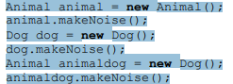

The output would be:

Talk

Bark

Bark

### Added code to the above driver, and printed output

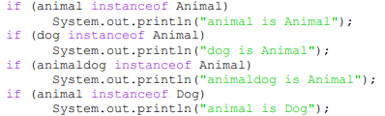

The output would be

Talk

Bark

Bark

Animal is Animal

Animaldog is Animal

### Demonstrate with examples how to downcast and upcast objects

